**Project Design Phase-II**

**Technology Stack (Architecture & Stack)**

|  |  |
| --- | --- |
| **Date** | 17 June 2025 |
| **Team ID** | LTVIP2025TMID34894 |
| **Project Name** | Sustainable Smart City Assistant Using IBM Granite LLM |
| **Maximum Marks** | 4 Marks |

**Technical Architecture Description**

The architecture of the **Sustainable Smart City Assistant** is designed using a modular and scalable cloud-based approach. It uses IBM’s Watsonx Granite LLM as the core language model for intelligent response generation and content summarization. The application

consists of multiple functional components integrated through a user-friendly web interface powered by Gradio and deployed on Google Colab for easy testing and demonstration.

**Table 1: Components & Technologies**

|  |  |  |  |
| --- | --- | --- | --- |
| **S.No** | **Component** | **Description** | **Technology** |
| **1** | User Interface | Frontend where user interacts with the assistant | Gradio (Python-based UI) |
| **2** | Application Logic-1 | Logic to process user inputs, handle file uploads, etc. | Python |
| **3** | Application Logic-2 | Natural Language Processing and Text Summarization | IBM Watsonx Granite LLM |
| **4** | Application Logic-3 | Sustainability Q&A, Eco Tips Generator, Anomaly Detection | IBM Watsonx Granite LLM |
| **5** | Database | Structured data storage (e.g., feedback submissions) | Pandas DataFrames + Excel (OpenPyXL) |
| **6** | Cloud Database | Temporarily handled using local files in Colab (for prototyping) | Local FileSystem (via Google Colab) |
| **7** | File Storage | Upload & process CSV for  forecasting/anomaly detection | Google Colab Local Filesystem |
| **8** | External API-1 | PyNgrok used for sharing app via public URL | PyNgrok API |

|  |  |  |  |
| --- | --- | --- | --- |
| **9** | External API-2 | Not used in current version | N/A |
| **10** | Machine Learning Model | Used for KPI forecasting and anomaly detection | Linear Regression (Scikit- learn), Statistical Z-Score |
| **11** | Infrastructure | Deployment & hosting | Google Colab (Jupyter Notebook Environment) |

**Table 2: Application Characteristics**

|  |  |  |  |
| --- | --- | --- | --- |
| **S.No** | **Characteristics** | **Description** | **Technology Used** |
| **1** | Open-Source Frameworks | Open-source libraries for model deployment, UI, and data handling | Gradio, Transformers, Scikit-learn, Pandas, PyNgrok |
| **2** | Security  Implementations | Data handled in-memory; no sensitive information stored | File restrictions, no external access enabled |
| **3** | Scalable  Architecture | Modular component-based  architecture; each function can be containerized later | Python Modules, Gradio Tabs (can be scaled via FastAPI) |
| **4** | Availability | Accessible via Ngrok tunneling in Colab; scalable to any cloud in future | Google Colab + PyNgrok |
| **5** | Performance | Lightweight interface; fast response from IBM Granite LLM (under 3 sec per call) | Transformers Library + IBM Granite Model |

**Solution Architecture diagram**

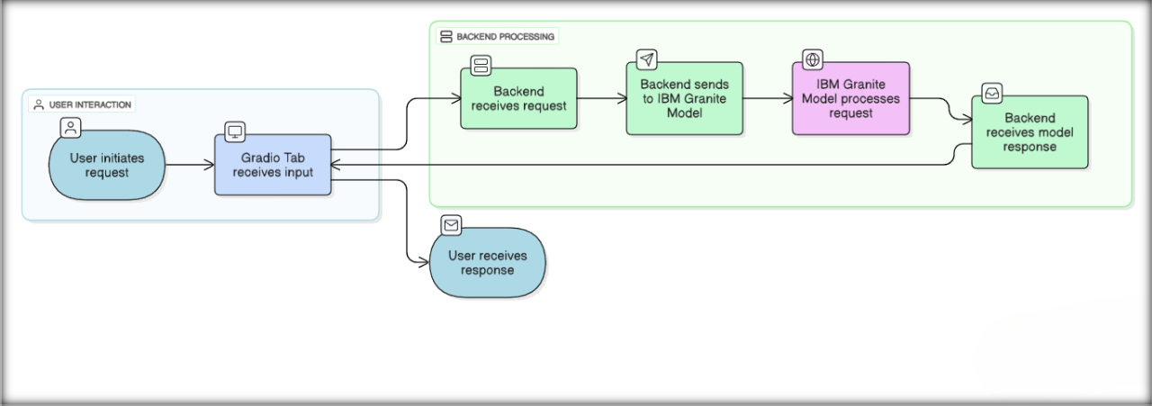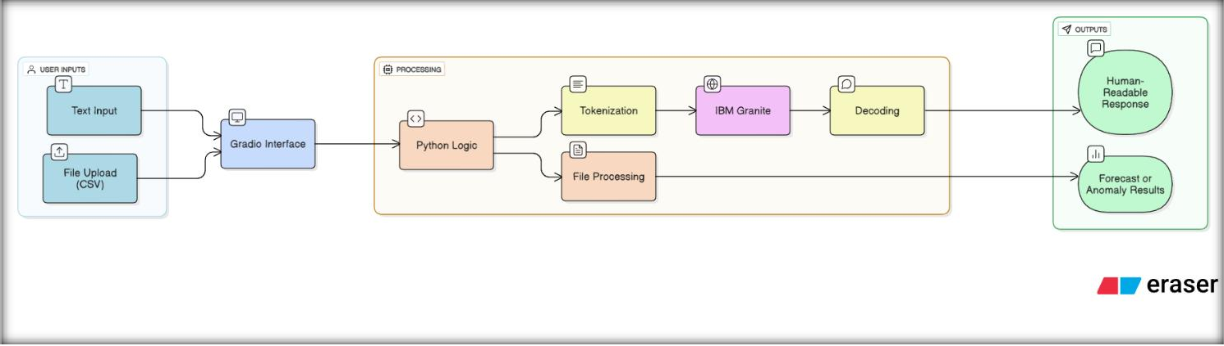

**Application flow:**